MGC AHB to APB Bridge (AHB2APB)

Functional Overview
The AHB to APB bridge converts host side AHB cycles to target side APB cycles. The APB side of the bridge supports up to 8 slaves and incorporates the multiplexing logic for the response path from the APB slaves to their AHB host.

The bridge does not buffer transfers and does a one to one conversion of the AHB transfers to APB cycles. AHB bursts are not directly supported, the bridge simply responds to AHB NONSEQ and SEQ transfer states and latches the necessary pipelined control signals in order to create an APB transfer. The timing relationships between signals on both interfaces is documented in the ARM Amba specification.

The bridge has a number of parameters which are used to specify the number of APB channels and the address map for each one. Any AHB accesses to non-mapped addresses result in a null response from the bridge. The bridge contains no registers.

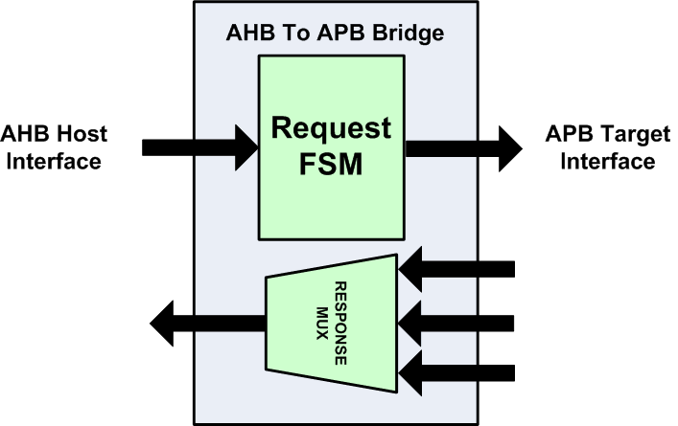
AHB to APB Bridge Functional block diagram

Bridge Design Parameters
Name | Type | Default | Description
NO_OF_SLAVES | int | 8 | Defines the number of slaves – valid range 1-8
SLAVE_START_ADDR_0 | int | 0 | Start address for slave selected by PSEL[0]
SLAVE_END_ADDR_0 | int | 32’hff | End address for the slave selected by PSEL[0]
SLAVE_START_ADDR_1 | int | 32’h100 | Start address for slave selected by PSEL[1]
SLAVE_END_ADDR_1 | int | 32’h1ff | End address for the slave selected by PSEL[1]
SLAVE_START_ADDR_2 | int | 32’h200 | Start address for slave selected by PSEL[2]
SLAVE_END_ADDR_2 | int | 32’h2ff | End address for the slave selected by PSEL[2]
SLAVE_START_ADDR_3 | int | 32’h300 | Start address for slave selected by PSEL[3]
SLAVE_END_ADDR_3 | int | 32’h3ff | End address for the slave selected by PSEL[3]
SLAVE_START_ADDR_4 | int | 32’h400 | Start address for slave selected by PSEL[4]
SLAVE_END_ADDR_4 | int | 32’h4ff | End address for the slave selected by PSEL[4]
SLAVE_START_ADDR_5 | int | 32’h500 | Start address for slave selected by PSEL[5]
SLAVE_END_ADDR_5 | int | 32’h5ff | End address for the slave selected by PSEL[5]
SLAVE_START_ADDR_6 | int | 32’h600 | Start address for slave selected by PSEL[6]
SLAVE_END_ADDR_6 | int | 32’h6ff | End address for the slave selected by PSEL[6]
SLAVE_START_ADDR_7 | int | 32’h700 | Start address for slave selected by PSEL[7]
SLAVE_END_ADDR_7 | int | 32’h7ff | End address for the slave selected by PSEL[7]

Input/Output Signal Description
Name | Width | Direction | Description
HCLK | 1 | Input | System clock, used by both sides of the bridge
HRESETn | 1 | Input | System synchronous reset, used by both sides of the  bridge
HADDR | 32 | Input | AHB Address used by bridge address decode
HTRANS | 2 | Input | AHB Transfer state
HWRITE | 1 | Input | AHB Write command signal
HSIZE | 3 | Input | AHB Size – all transfers are treated as 32 bit  transfers
HBURST | 3 | Input | AHB Burst type
HPROT | 4 | Input | AHB Access protection encoding
HWDATA | 32 | Input | AHB Write data
HSEL | 1 | Input | AHB Select line
HRDATA | 32 | Output | AHB read data
HREADY | 1 | Output | AHB ready, used to signal bus cycle completion
HRESP | 2 | Output | AHB Response field
PADDR | 32 | Output | APB Address, a pipelined version of the AHB address
PWDATA | 32 | Output | APB Write data
PENABLE | 1 | Output | APB Peripheral enable
PSEL | NO_OF_SLAVES | Output | APB Peripheral select – one per slave
PRDATA | 32 *[NO_OF_SLAVES] | Input | APB Read data – 32 bits x number of slaves
PREADY | [NO_OF_SLAVES] | Input | APB Ready, one for each slave
PSELVERR | [NO_OF_SLAVES] | Input | APB Error indication, one for each slave

